Asymptotic Notations
Informal Introduction
Informally, O(g(n)) is the set of all functions with a lower or same order of growth as g(n)
n є O(n²), 100n + 5 є O(n²), (n(n − 1))/2 є O(n²).

The second notation, Ω(g(n)), stands for the set of all functions with a higher or same order of growth as g(n)

Finally, Ɵ(g(n)) is the set of all functions that have the same order of growth as g(n)

O-notation
DEFINITION A function t (n) is said to be in O(g(n)), denoted t (n) ∈ O(g(n)), if t (n) is bounded above by some constant multiple of g(n) for all large n, i.e., if there exist some positive constant c and some nonnegative integer n₀ such that
t (n) ≤ cg(n) for all n ≥ n₀.
100n + 5 є O(n²). Indeed,
100n + 5 ≤ 100n + n (for all n ≥ 5) = 101n ≤ 101n².
Thus, as values of the constants c and n₀ required by the definition, we can take 101 and 5, respectively.
Another specific values for constants c and n₀ is
100n + 5 ≤ 100n + 5n (for all n ≥ 1) = 105n
c = 105 and n₀ = 1.

Ω -notation
DEFINITION A function t (n) is said to be in Ω (g(n)), denoted t (n) є Ω (g(n)), if t (n) is bounded below by some positive constant multiple of g(n) for all large n, i.e., if there exist some positive constant c and some nonnegative integer n0 such that
t (n) ≥ cg(n) for all n ≥ n0.
n³ є Ω (n²):
n³ ≥ n² for all n ≥ 0,
i.e., c = 1 and n₀ = 0.

Ɵ -notation
DEFINITION A function t (n) is said to be in Ɵ (g(n)), denoted t (n) ∈Ɵ (g(n)), if t (n) is bounded both above and below by some positive constant multiples of g(n) for all large n, i.e., if there exist some positive constants c₁ and c₂ and some nonnegative integer n₀ such that
c₂g(n) ≤ t (n) ≤ c₁g(n) for all n ≥ n₀.
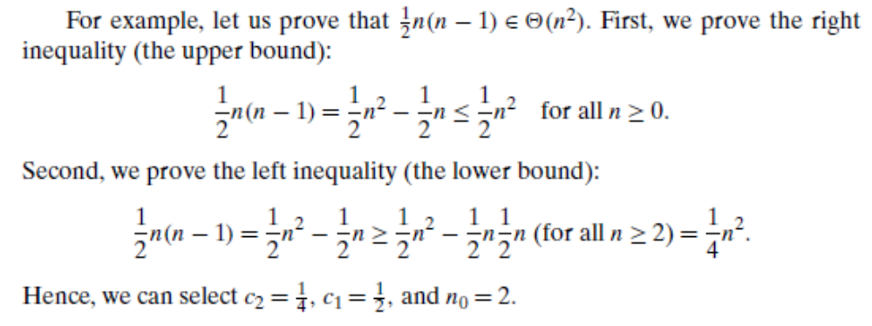

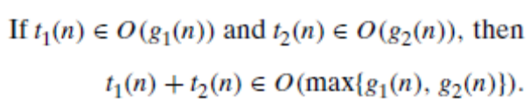
Using Limits for Comparing Orders of Growth
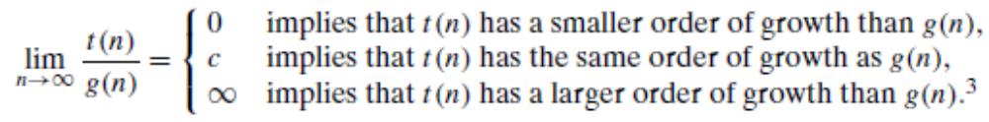
EXAMPLE 1 Compare the orders of growth of (n(n − 1))/2 and n².
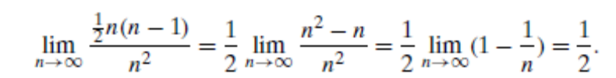
EXAMPLE 2 Compare the orders of growth of log₂ n and √n.
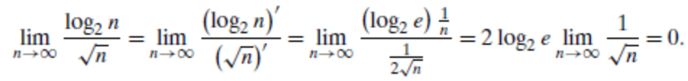

EXAMPLE 3 Compare the orders of growth of n! and 2n.
